Our October Visit to Prospect Point, Blue Mtn. Lake, NY - October 2021

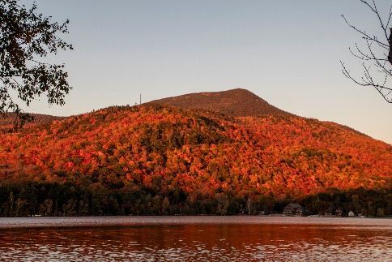Our October time schedule brings us to visit [Prospect Point Cottages](http://prospectpt.com/) on Blue Mountain Lake, NY. It looked like the weather conditions could be excellent for a relaxing outdoors excursion and decided to travel w/o the kayaks.

The weather was a mixture of clouds, fog, wind, light rain, with an ocassional sun appearance which did give us wonderful opportunities to spend more time on land exploring the area.The days began with our 3.7 mile morning walk from our cottage down to Durant Lake and around the village and beyond. This spring, the Chef Darrell’s Diner on Rt. 30 opened and, since we had to pass it each morning, we started the days with excellent breakfasts. Hikes to Newcomb, Buttermilk Falls, Death Brook and its waterfall were memoriable and very peaceful.

What a beautiful time of year to roam outside each day and see a different scene unfold. Next year is already inked in!

And for the photos, click [Prospect Point – October 2021.](https://photos.app.goo.gl/rYQmfXsV9wPK9HqW7)

And for sounds from BML just outside our [cottage](https://fauxes.net/Sounds/Condo%20Sounds/Cabin%20rain%202-PP-October%207%202020%20113148%20AM.mp3) and along with the Death Brook [stream](https://fauxes.net/Sounds/Condo%20Sounds/Death%20Brook%20little%20stream-%20October%201%202021%20112807%20A.mp3) and its [waterfall](https://fauxes.net/Sounds/Condo%20Sounds/Death%20Brook%20Waterfalls%20-%20October%201%202021%20113716%20AM.mp3).